ABYSS Project
Multi-disciplinary Project – 2006 IS1 v1.0
Abyss User manual.
Group n 307
5/5/2007



Table of Contents

Introduction 4
About Abyss Client 4
Arborescence of the screens 5
Launching/Authentication 6
Objectives of this screen 6
Troubleshooting 6
Main Window 7
Objectives of this screen 7
Troubleshooting 7
Active Directory 8
Manage Users 8
Objectives of this screen 8
Troubleshooting 9
Manage Computers 10
Objectives of this screen 10
Troubleshooting 11
Manage Groups 12
Objectives of this screen 12
Troubleshooting 14
Oracle 10g 15
Main window 15
Objectives of this screen 15
Troubleshooting 15
Execute SQL Scripts 16
Objectives of this screen 16
Troubleshooting 16
Manage Users 17
Objectives of this screen 17
Troubleshooting 18
Manage Tables 19
Objectives of this screen 19
Troubleshooting 19
Manage Views 20
Objectives of this screen 20
Troubleshooting 21

Introduction

Welcome to the official documentation of Abyss Client. Abyss System thanks you for using this product and hope that your experience will be rewarding and constructive. This documentation explains in detail the functionality of Abyss Client for a better utilization from users.

About Abyss Client

Abyss Client is the all in one administrative application for industrial production server based on Windows 2003 Server R2 and Oracle Database 10g R1/R2.

If you have just acquired Abyss Client and want to use it, follow the guide step by step to obtain an operational server with Active Directory and Oracle Database in function.

Abyss Client can be executed directly from your server, a computer of your domain or from a distant client (on the same local network of your server) who has administrative rights.

Arborescence of the screens

Login
 | Active Directory Administration. | Management of Active Directory objects.
 | Active Directory User. | Creation/Modification of user.
 | Member of Information. | Management of member of list from user.
 | Reset Password. | Reset user password.
 | Active Directory Computer. | Creation/Modification of computer.
 | Member of Information. | Management of member of list from computer.
 | Active Directory Group. | Creation/Modification of group.
 | Member of Information. | Management of member of list from group.
 | Members Information. | Management of members list from group.
 | About | Information About members of this project.
 | Oracle Administration. | Management of Oracle objects.
 | Oracle User. | Creation/Modification of external user
 | Oracle Table. | Creation/Modification of table.
 | Oracle View | Creation/Modification of view.
Quit

Launching/Authentication

Objectives of this screen

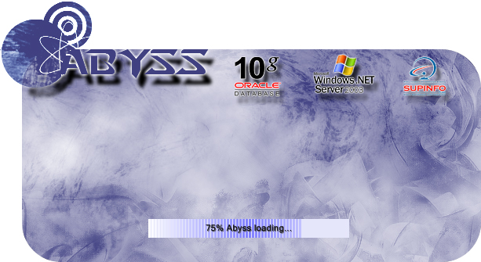
When you launch Abyss Client, please wait during the loading.

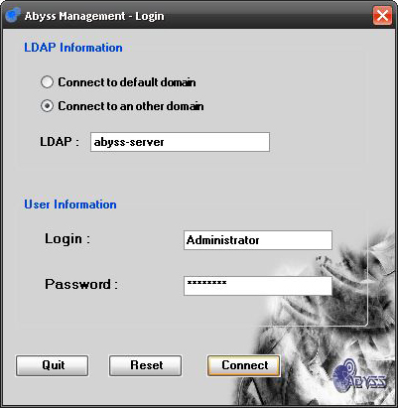
Then, you can log you to your domain with your Login and your Password.
For the domain’s connection, you have the choice to connect to your default domain or another domain.

Troubleshooting
If the information you tapped is not correct, the connection will fail.
If the data base is not accessible, it will generate an error message.
Main Window

Objectives of this screen

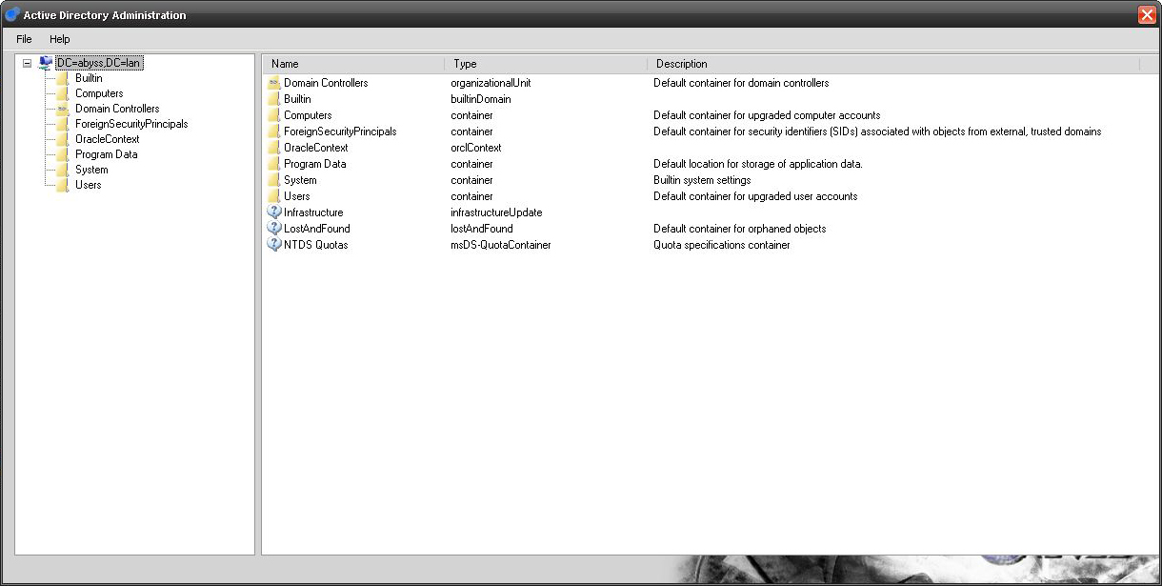
The first window shows your Domain Architecture directly from Active Directory. You can see your Users, your Computers, and your Groups and create/modify them.
You can see too a lot of information about your Domain and connect to the Oracle Administration’s part.

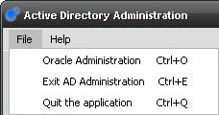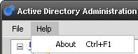
By clicking on File in the top right corner, you can turn to “Oracle Administration”, “Exit Active Directory or “Quit the Application”. You can too use some shortcuts likes “Ctrl+O” for Oracle Administration, “Ctrl+E” for “Exit AD Administration” and “Ctrl+Q” to “Quit the application”.
In the Help tab, you can show some information about developers (or press “Ctrl+F1”).

Troubleshooting
If the active directory domain you connected is no longer accessible, it will generate an error.

Active Directory

Manage Users

Objectives of this screen

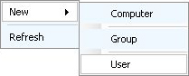
To Create a User, make a right click somewhere on the tree view and click on User.

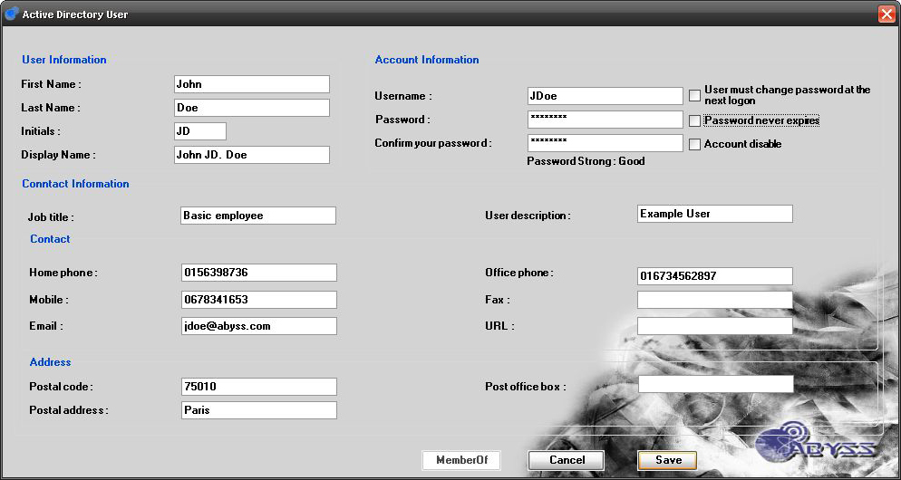
The User’s window open and allow you to create one. All the fields are not mandatory.
If you click the button “Save”, and there are mandatory fields, they will turn red.

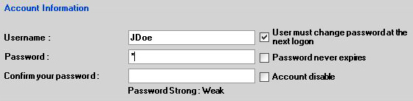

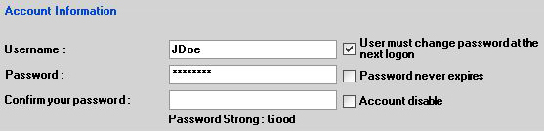

When you enter the password, a checkout is done about the toughness. If you choose that password never expires, a popup appear and says that “The user will not be required to change the password at next logon”.
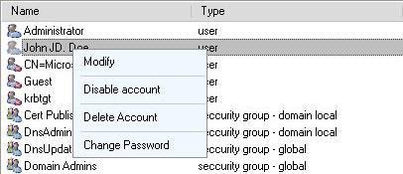
Make a right click on your User to “Enable” or “Disable” it. The icon change when a User is disabling.
You can too “Delete” this object or “Modify” it.
You can also “Change password”.

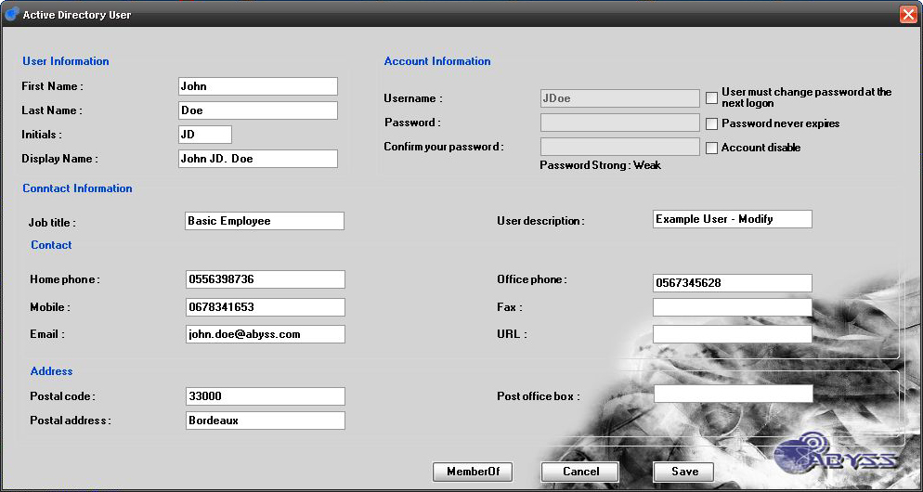
When you modify a User, the User’s window open filled. You can change the value of all properties and add the User to a Group by clicking on “MemberOf”.
In the “MemberOf” window, double click on the group desired to add it.

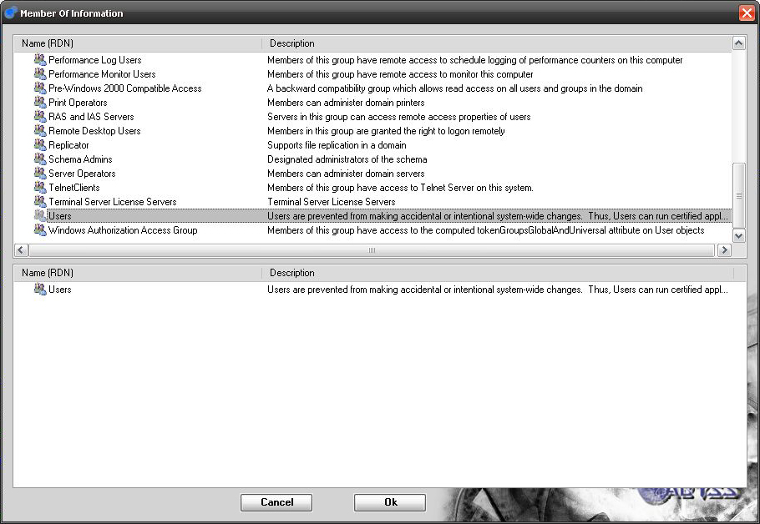

Troubleshooting
If the active directory domain you connected is no longer accessible, it will generate an error.

Manage Computers

Objectives of this screen

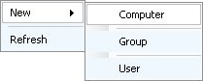
To Create a Computer, make a right click somewhere on the tree view and click on Computer.

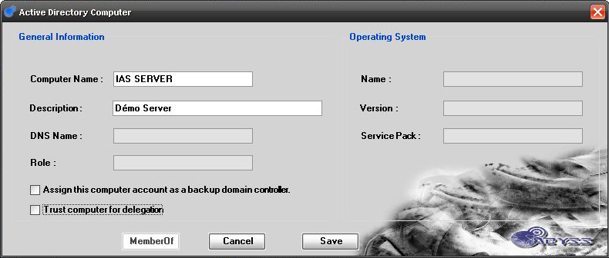
The Computer’s window open and allow you to create one. If you check “Trust computer for delegation”, a popup alarm you that this is a security-sensitive operation.

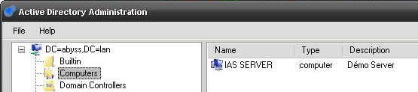
After creation, you can see your Computer in the main window.

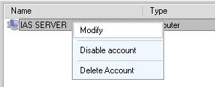
Make a right click on it to “Enable” or “Disable” your Computer.
You can too “Delete” this object or “Modify” it.
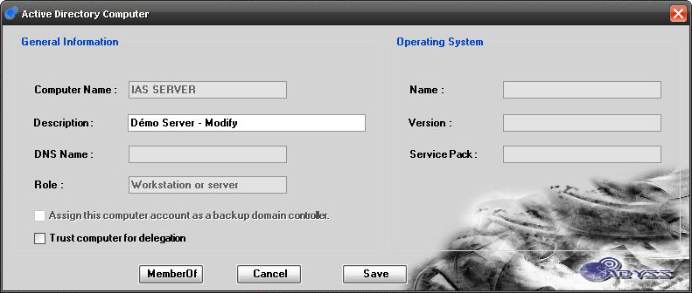
When you modify a Computer, the Computer’s window open filled. You can change the Description and some properties. You can also add the Computer to a Group by clicking on “MemberOf”.

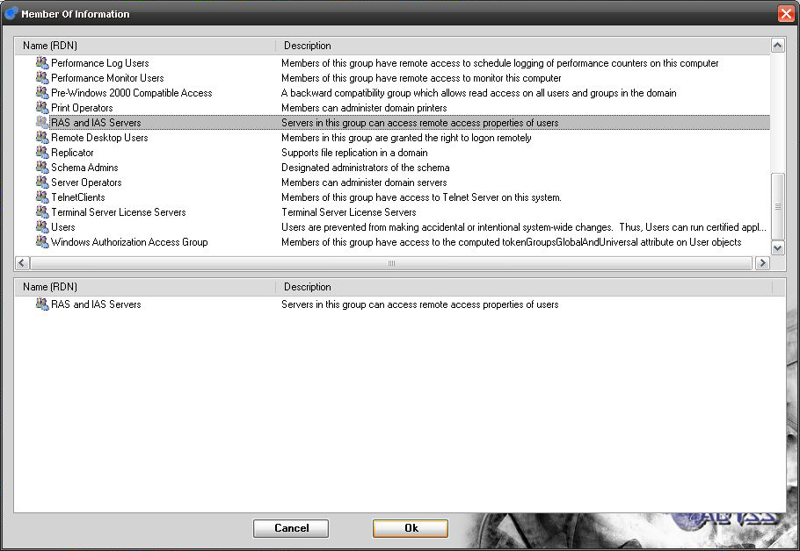
In the “MemberOf” window, double click on the group desired to add it.

Troubleshooting
If the active directory domain you connected is no longer accessible, it will generate an error.

Manage Groups

Objectives of this screen

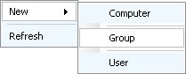
To Create a Group, make a right click somewhere on the tree view and click on Group.

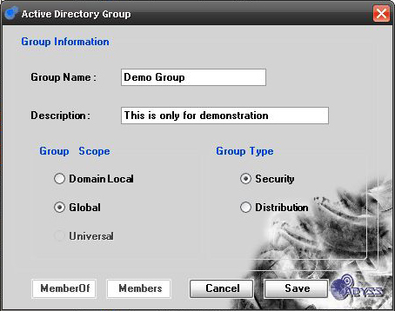
The Group’s window open and allow you to create one.

If you check “Security” in “Group Type”, you will not be allowed to check “Universal” in “Group Scope”.
A Universal Group can only be a Distribution’s Group.

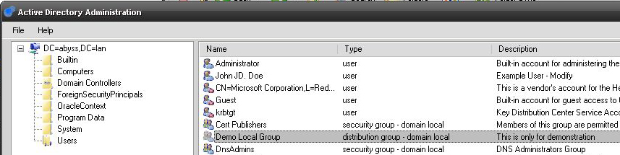
After creation, you can see your Group in the main window.

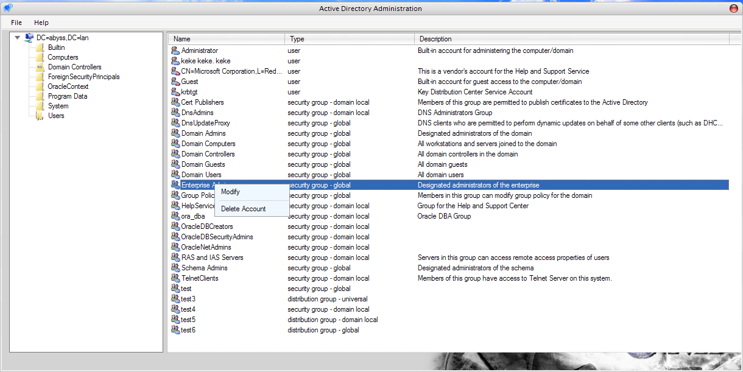

Make a right click on it to “Modify” or “Delete” your Group.

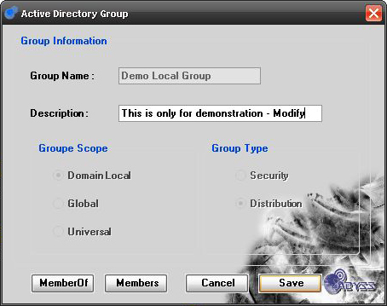
When you modify a Group, the Group’s window open filled.
You can change the Description.
You can also add the Group to another Group by clicking on “MemberOf” and assign it other members with the “Members”’s button.

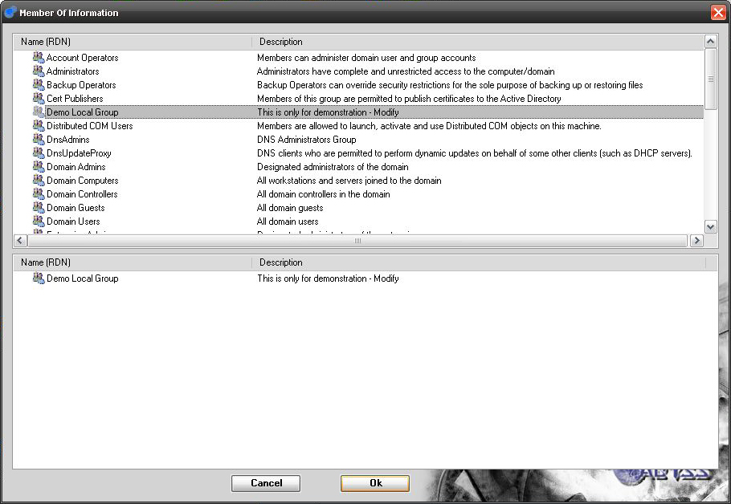
In the “MemberOf” window, double click on the group desired to add it.

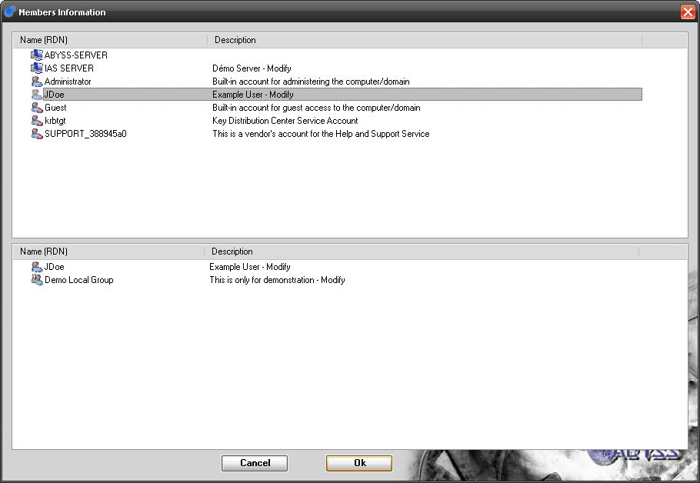
In the “Member” window, double click on objects desired (Users, Computers and Groups) to add them on your group.

You can also attribute directly a group to your objects (Users, Computers and Groups) by “Modify” them and click on “MemberOf”.

Troubleshooting
If the active directory domain you connected is no longer accessible, it will generate an error.

Oracle 10g

Main window

Objectives of this screen

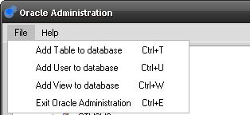
In the Oracle part, in “File”, you can Add Table (Ctrl+T), Add User (Ctrl+U), Add View (Ctrl+W) or exit Oracle Administration.

In the Help tab, you can show some information about developers (or press “Ctrl+F1”).

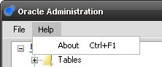

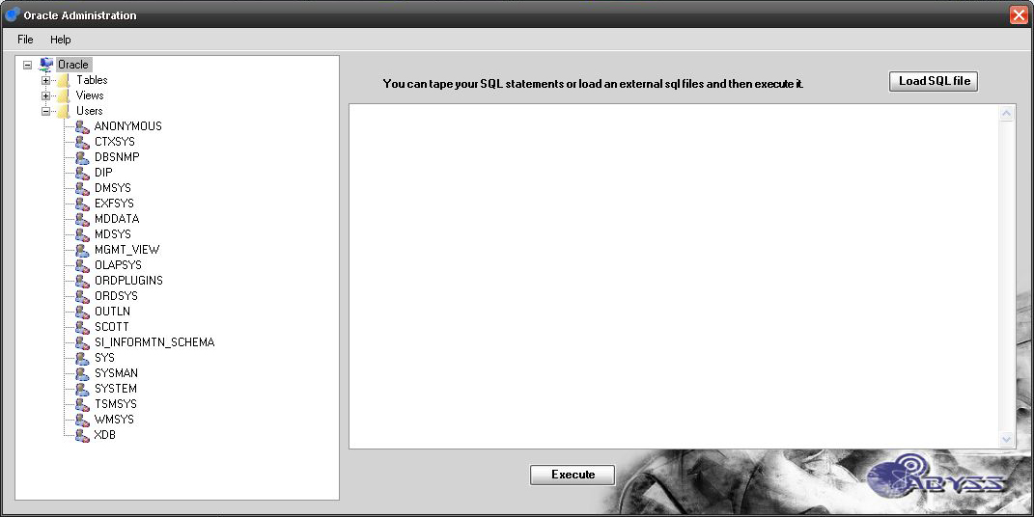
The Main window allows you to Modify or Enable/Disable “Users” and Modify “Views” and “Tables”. You can also Load SQL file and execute your SQL script on your database.

Troubleshooting
If the oracle data base you connected is no longer accessible, it will generate an error.

Execute SQL Scripts

Objectives of this screen

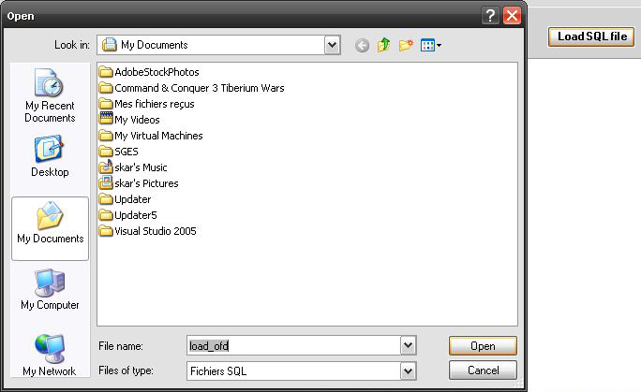
In the main window, click on “Load SQL file”. It opens a new window to find your file.

Double click on it and the file’s content will open in the right part of the main window.

Then, you can “Execute” it.

Troubleshooting
Nothing

Manage Users

Objectives of this screen

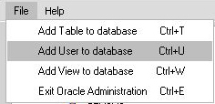
To create an User, click on “File” and “Add User to database” (or Ctrl+U).

A new window opens.

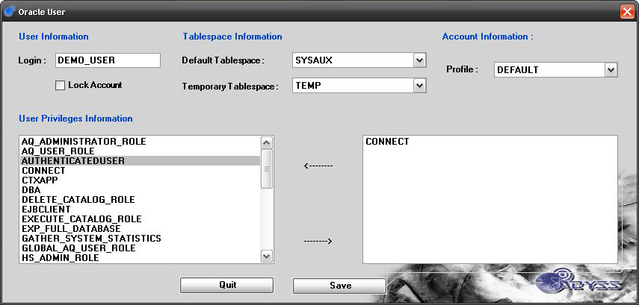
You can now enter User‘s information like is “Login”, choose his “Default Tablespace” and “Temporary Tablespace”. You can too attribute his “Profile” and some “Privileges”.

Then, “Save” to create your User.
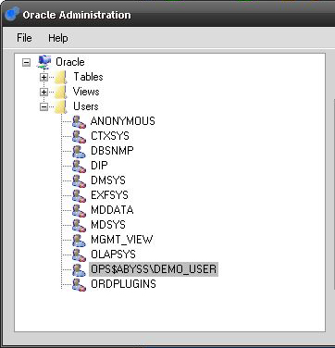
Once your user created, you can see it in “Users” tab in the main Oracle‘s window.

It may be required to refresh the list (right click on “Users” and “Refresh”.

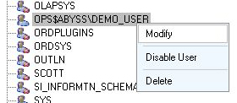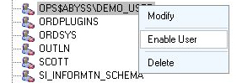
Then, you can “Modify” it (it open the “User” window filled),”Disable” or ”Enable” it and “Delete” this entry.

The icon change when a User is disabling.

Troubleshooting
If the oracle data base you connected is no longer accessible, it will generate an error.

Manage Tables

Objectives of this screen

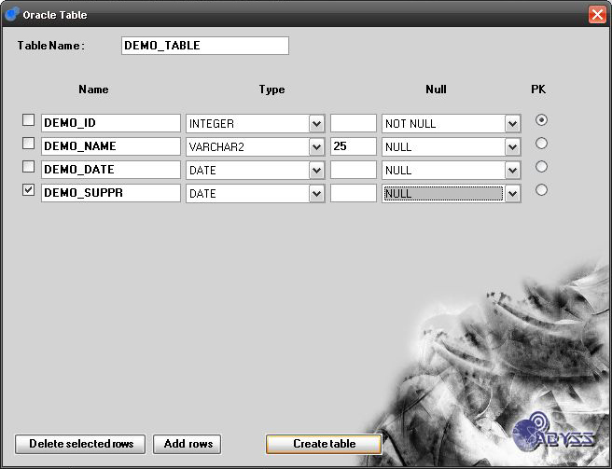
To create “Tables”, click on “File” and “Add Table to database” (or Ctrl+T).

On the Table window, you can specify the Table Name and Add some rows.

Then, enter properties of your rows, specify the Primary Key (PK) and click on “Create table”.
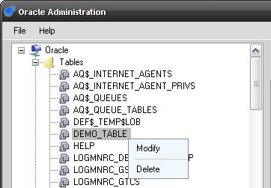
Once your table created, you can see it in “Tables” tab in the main Oracle‘s window.

It may be required to refresh the list (right click on “Tables” and “Refresh”.

Then, you can “Modify” it (it open the “Table” window filled) or Delete it.

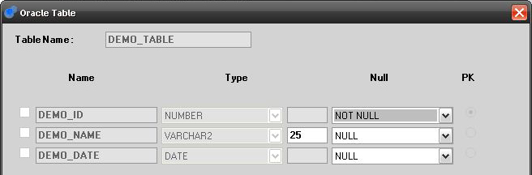
When you decide to “Modify” a Table, you can “Add” or “Delete” some rows and modify some row’s values.

Troubleshooting
If the oracle data base you connected is no longer accessible, it will generate an error.

Manage Views

Objectives of this screen
To create “Views”, click on “File” and “Add View to database” (or Ctrl+W).

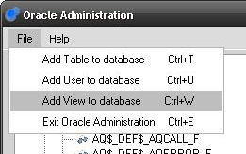

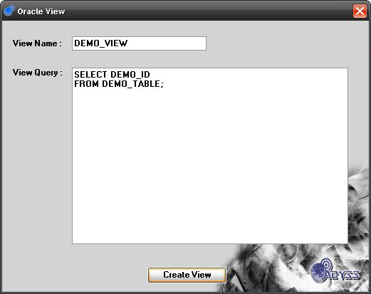
On the View window, you can enter your SQL Query and specify the view’s name.

Then, click on “Create View”.

Once your view created, you can see it in “Views” tab in the main Oracle‘s window.

It may be required to refresh the list (right click on “Views” and “Refresh”.

Then, you can “Modify” it (it open the “View” window filled) or Delete it.

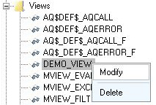

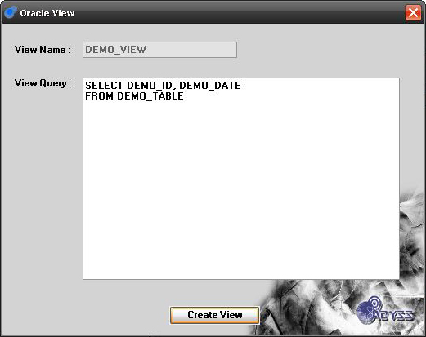
When you decide to “Modify” a View, you can modify the Query and execute it.

Troubleshooting
If the oracle data base you connected is no longer accessible, it will generate an error.

